 [Translated from Portuguese to English - www.onlinedoctranslator.com](https://www.onlinedoctranslator.com/en/?utm_source=onlinedoctranslator&utm_medium=docx&utm_campaign=attribution)



Create Direct Mail Merge

**Instruction manual**

**Ver. 1.0**

**::Instructions in English**

::Introduction

Thank you for downloading and using MailMerge.

Hello! I'm Richard Slater, I created this app to satisfy a need I felt at work. At the beginning of each period I need to create several types of direct mail, for example direct mail containing user login data and information on how to get to the website of the company where I work. This is a very complicated task because generally the number of new clients easily exceeds six hundred, so I generate a mail merge in Microsoft Word using the standard resources, but I still need to separate the generated files, saving them in PDF and renaming each one with the customer's name or other information that makes it easy to distinguish who they are from. This is the login without having to open the file, so I can send the correct file to the client's whastapp or email without running the risk of sending the wrong file. All of this takes a long time and is a painful task, with this in mind I created MailMege, a fantastic tool where you can create mail in word and save the result as a doc or pdf or even a copy in pdf and another in doc in just a few minutes, So work that would take days to complete is now ready in minutes.

With mailMerge it is possible to add prefixes and suffixes, entering any name or selecting information from the database, be it an access database or an xls spreadsheet, all of this is done in an assisted and dynamic way, avoiding errors or arduous tasks.

I hope this app is really useful for you as it is for me, and if you want you can make donations from as little as $1.00 to the project and help it improve and create many other free projects, I would be very happy. I have great ideas for apps for all kinds of expensive or time-consuming services.

You can use MailMerge personally or professionally and there are no limits on usage, resources or computers.

Use it, share it with your friends and follow us on our social networks to help the project become great, we will all be happy in the end.

**::Download and Installation**

1. Download MailMerge on Github using the link below, it is not necessary to have a Github account to be able to download it.

<https://github.com/Richard1057/MailMerge.git>

1. Click on the blue button called “Code”

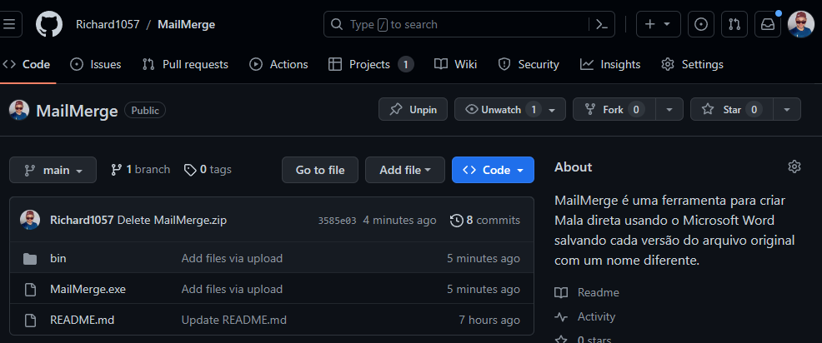

1. Click on the “Download ZIP” option.

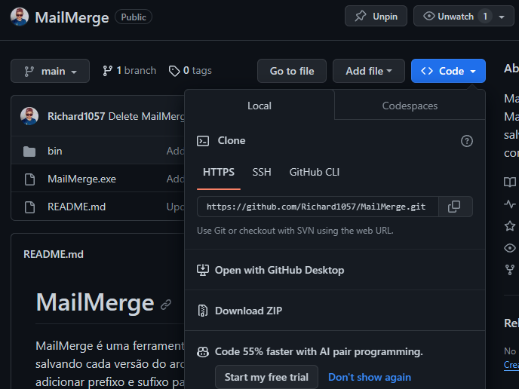

1. Save the file in an easily accessible location on your computer, such as in the Download or Documents folder, for example.
2. Navigate to the folder where the file was downloaded, right-click the MailMerge-main.zip file and click Extract here.

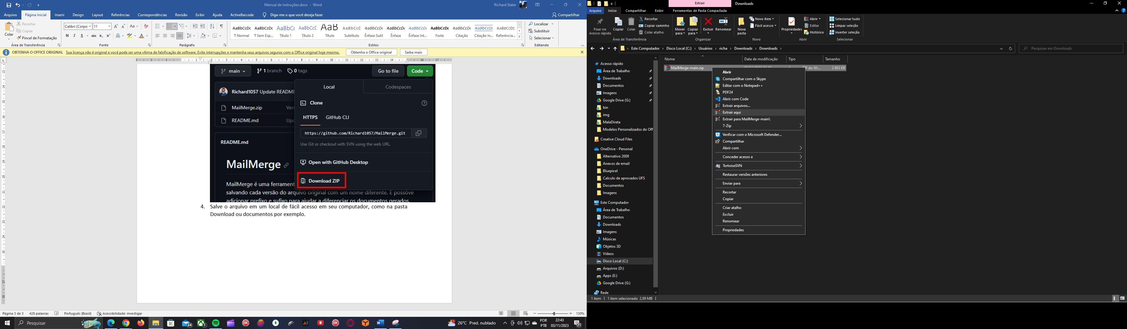

1. Access the newly created folder “MailMerge-main” and rename it by removing the -main from the folder name, giving it the name MailMerge.
2. Copy the newly renamed “MailMerge” folder to a permanent location of your choice, this location cannot be removable drives or network locations.

Inside the MailMerge folder you can find the executable MailMerge.exe and a bin folder, do not delete or renew this folder or its files.

The MailMerge folder and the MailMerge.exe executable can be renamed if you wish, but the bin folder and its files cannot be renamed.

:: Creating the bank

Both access and excel databases are compatible, with no difference between one and the other in terms of performance. For some people, excel may be an easier-to-use alternative, while others prefer access, for example, I prefer access.

See how to create your database in both technologies.

1. **Creating the database in exel**

This part is the easiest of all, simply create a new spreadsheet and add the fields as shown in the image.

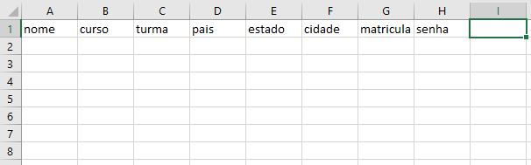

If you want, you can add the records now too, or you can do it later, I preferred to add the records now.

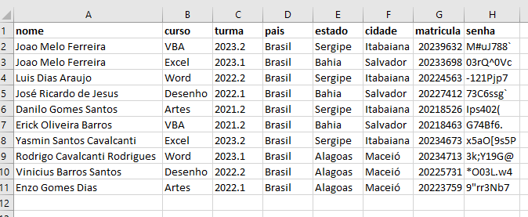

*\*\*\* All names are fictitious and were generated using the portal*[*https://pt.fakenamegenerator.com/*](https://pt.fakenamegenerator.com/)*any similarity is mere knowledge.*

Save your spreadsheet in *.xls format (old Excel format, do not save in *.xlsx format as it is not yet compatible), in a location and name that are easy to remember.

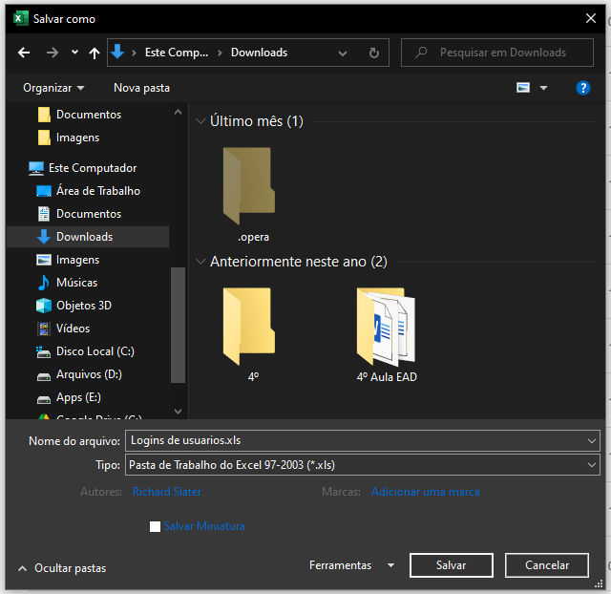

You can close Excel now, we won't use it anymore for now.

1. **Creating a database in Access**

* Create a new database by clicking the Blank Database button when starting Access.

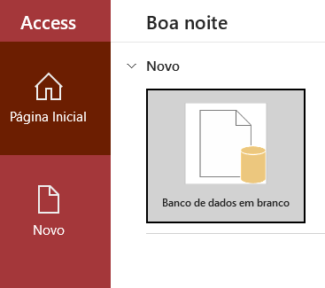

* On the screen that appears, give a name to your database and select the folder where you want to save it, remember to give it a name that is easy to remember later and place it in an easily accessible location, then click on create button.

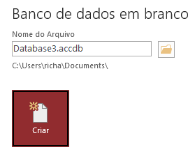

* In the Save As dialog box, enter the name of your table, this is not the same name as your file.

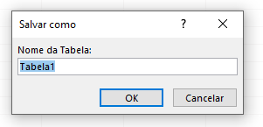

you can have as many tables as you need within the same file. For example, within a file called Customers, you can have a table with purchasing data, another table with personal data, etc. In mailMerge you can select which table you want to use if there are more than one in the same file.

* A screen similar to the one in the image below will be shown.

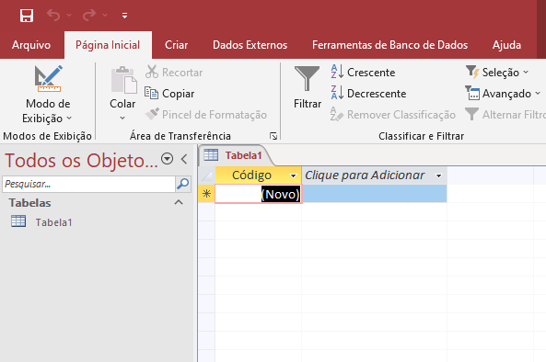

* Click the View button to change the view to Design to make it possible to create, modify or delete fields.

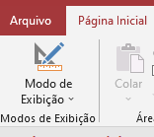

* The table will switch to database design mode.

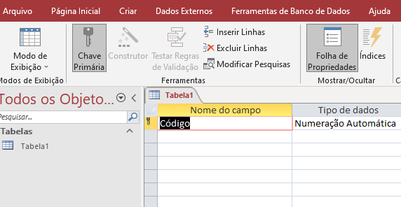

* 1. If you do not use the delete code field, or if you just want to press the down arrow key to add a new field, the field type will be set to “Short Text” automatically by Access. Continue adding all the fields you need, see what the table looks like for our example.

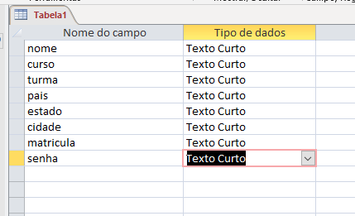

* 1. Click the View button again, save the changes to the table by clicking yes in the dialog that appears.

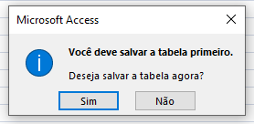

Also save the file by clicking on the save icon.

* 1. Now fill in the data for each field, see what our example looks like.

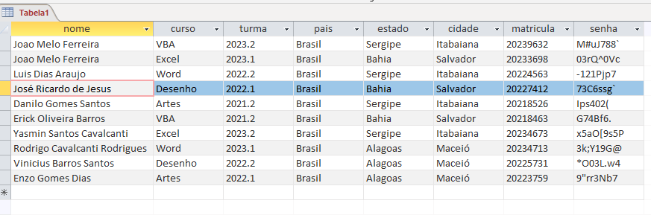

*\*\*\* All names are fictitious and were generated using the portal*[*https://pt.fakenamegenerator.com/*](https://pt.fakenamegenerator.com/)*any similarity is mere knowledge.*

It's a good idea to save a copy of your Access database in the old format. Also, for some unknown reason, I noticed that on some systems the new *.accdb format is not read correctly.

To save a copy in the old *.mdb format, click on the File Menu, Save As option, the following screen will be displayed.

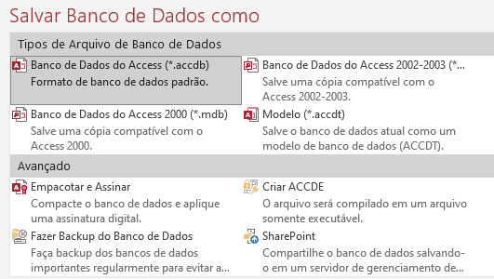

Click on the Access 2000 Database (*.mdb) option and click save, select the same name and location and click save again.

You can close Microsoft Access and if you are asked if you want to save the changes, click yes to save and close access.

**:: Creating the Document Template in Microsoft Word**

Now that you have created and fed your database with relevant information for your use, let's create our document model.

1. Create a new word document or open a document you want to use.

In this example, we will use a direct mailing with the login data of the users of an Enrollment form for a fictitious online course system.

The unique data belonging to each user will be:

* Name, id, course, class, country, state, city, registration, password.

We will use the following text in our, if you don't have a document but want to train, copy and paste the text below into a new word document.

====================++++++++++++++++++++++++===========================

Hello name, welcome! We are happy that you have joined our course, in the class class, we have many other users from your location, country, state, city, they will be happy to know that you are now part of the class, take the opportunity to break the ice by sending us a hello ! in group chat.

Your login details are:

User: enrollment

Password: password

*Att,*

*Richard Slater*

*Pedagogical Coordinator*

====================++++++++++++++++++++++++==========================

1. **Creating fields in the document**

MailMerge does not use the standard word mail merge fields, instead it uses indicators, if your document already has standard word mail merge fields you can follow the steps below without any problem.

4.1 Now we will mark in the document the place where we would like the field information to appear and we will also create the fields in the document all at once. To do this, select the name of the field in the document. Do not select spaces after the field name as they will also be replaced.



4.2 Click on the Insert tab and then on the Indicator button.

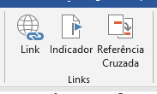

4.3 Enter the name of the field, in this case NAME and click add.

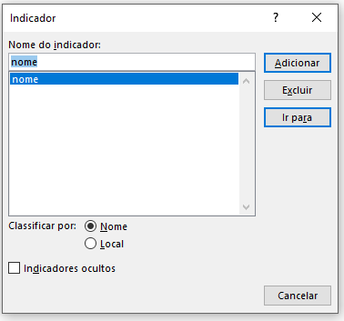

Repeat steps 4.1, 4.2 and 4.3 to add all fields to your document.

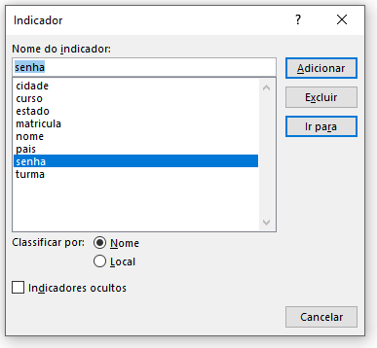

Be careful to type the field names exactly as you typed them in the Excel spreadsheet or Access database to avoid errors that are difficult to resolve.

You can select any word in your document to indicate that it is the desired place to insert the information, it is not mandatory that the word in the document has the name of the field in the data collection, but we will make both identical to facilitate the maintenance of the direct mail .

Now that you've added all the fields you need to your document, it's time to save.

* 1. Click Save as and under file type select *.dotx or *.dot and give the file an easy-to-remember name. Word will suggest that the file be saved in the office templates folder, this is the best folder to save it but you can save it in any other folder you want.

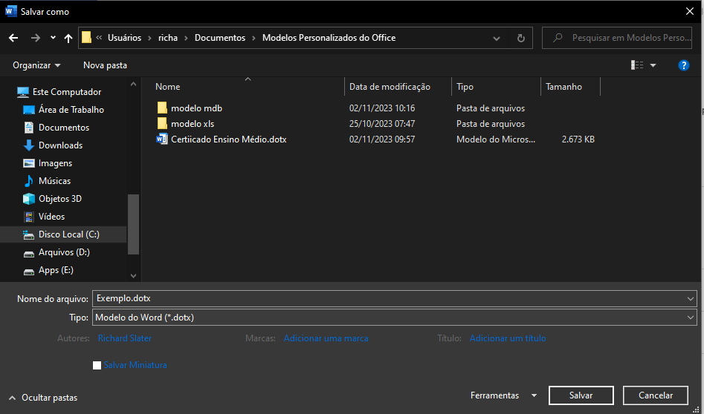

* 1. Click and Save.

Everything ok so far, your database and the direct mail model have been created successfully. You can close Word, now let's create the mail merge itself using MailMerge.

1. **Started MailMerge for the first time**

As this is a file downloaded from the internet, perhaps Windows Defender can give you a warning but don't worry, there is no virus or malicious artifacts in the file and feel free to run the antivirus if you wish.

5.1. To start the app, it's very simple, just double-click on the “MailMerge.exe” executable, no installation necessary, the executable will start immediately.

The good lives screen will be shown

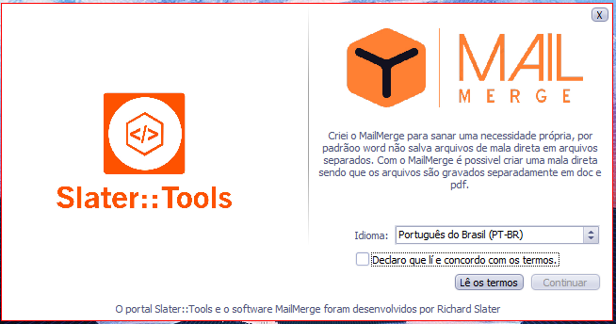

MailMerge is localized in three languages, Portuguese, Spanish and English.

* Select one of the available languages. (You can change the dioma later if you wish)
* Click the Read terms button to read our terms of use.
* Accept the terms by clicking on the checkbox.
* Click the Continue button and MailMerge will finally save your choices and start.

This is the launched application screen. As you can see, only the Select button is available.

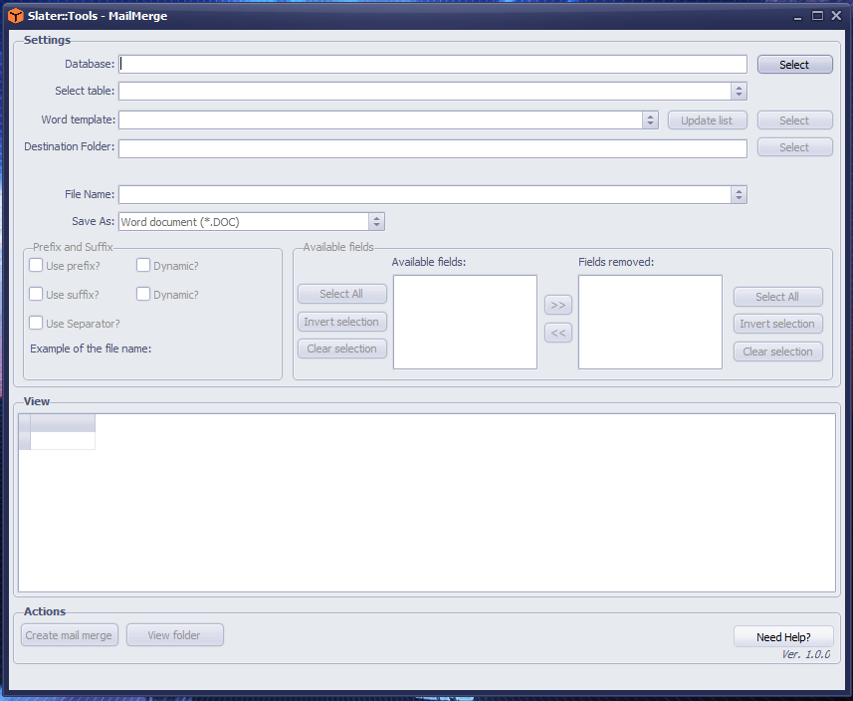

See now the sequence of steps to generate the mail merge using Microsoft Word, our example file and the database created previously or another one of your choice.

**5.2. Our Database has been selected.**

**5.2.1 Select your database by clicking the Select button**



**5.2.2 Click on the combobox to select the desired table if there is more than one**



**5.2.3 Click on the combobox to select your model, click on the Update list button if your model does not appear or click on the Select button to enter your document model manually.**



**5.2.4 Click on the select buttonto select the folder where you want to save the files that will be generated.**



**5.2.5 Click on the combobox to select the field in your database that will give rise to your file name.**



**5.2.6 Select the type of file that will be generated:**



**\*.doc – To save as a standard Word Document**



**\*.pdf – To save as a PDF Document**



**\*.doc and *.pdf – Both formats will be created.**

**5.3 Prefix and Suffix**

*PS Prefix and Suffix are not mandatory.*

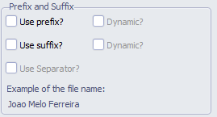

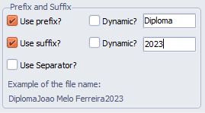

If you want to add a prefix or suffix to your file name, simply select the desired options and enter the name in the text box.

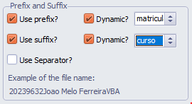

If you want to dynamically create the prefix and suffix, select the desired option and select in the combobox which field in the table will name the prefix or suffix.

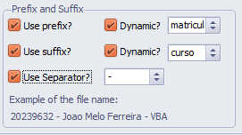

If you want to add a separator, check the Use Separator option and select the type in the combobox.

As you modify these items, you will be shown a preview of how your file name will be formed.

**5.4. Removing/Readding Fields**

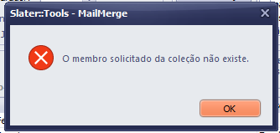If your database has fields that do not exist in your mail merge model, they need to be removed to avoid causing the No Member in Collection error.

This removal does not physically affect your database, it is only removed in memory.

*PS If this error occurs you will need to close MailMerge and start the whole process over again.*

Take a look at the area that shows all the fields available in your database.

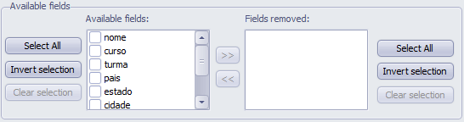

3

2

1

1

2

3

In this area we can see two designated areas, one containing all the database fields and three buttons, and another containing all the excluded fields and three buttons.

If you wish to remove a field, simply click on its name to select it from the Available fields list and then click on the transfer button (two arrows to the right), all selected fields will be removed from your database and will appear in the field list removed and will disappear from view. You can select more than one field at once and you can:

* Click button 1 to select all fields.
* Click button 2 to invert the selection.
* Click button 3 to clear the selection of all fields.

If you removed a field by mistake or regretted it, you can simply re-add it by clicking on its name to select it from the Removed Fields list and then click on the transfer button (two arrows to the left), all selected fields will be re-added to your database and will appear in the list of available fields and will reappear in the view. You can select more than one field at once and you can:

* Click button 1 to select all fields.
* Click button 2 to invert the selection.
* Click button 3 to clear the selection of all fields.

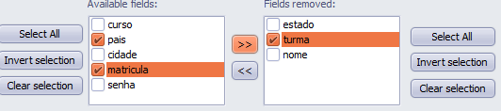

**5.5. Generating the direct mail itself**



Click on the Create mail merge button to start the creation process, once started you cannot stop this process, you can monitor the progress by observing the count in the progress bar that appears just above the data visualization list.

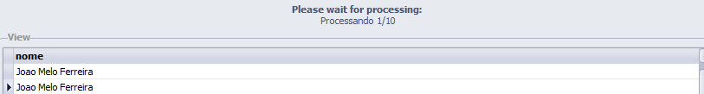

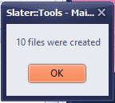Soon after the end of processing, a message will be displayed informing the total number of documents created.

The View Folder button will now be available and you can click it to view the folder where your new documents were saved.

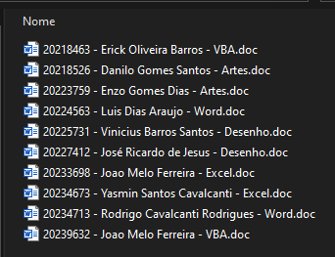All your files will be shown in the folder where you indicated they should be saved.

I hope that MailMerge is actually as useful for you as it is for me.

If you can, follow me on my social media profiles, make a donation starting from $1.00 (one dollar) this will help us keep this project in development and create many other free projects.

If you need help, you can consult the help menu to access video tutorials on our YouTube channel or request help on Telegram, Facebook or the WhatsApp community, in this menu you can also change the language.



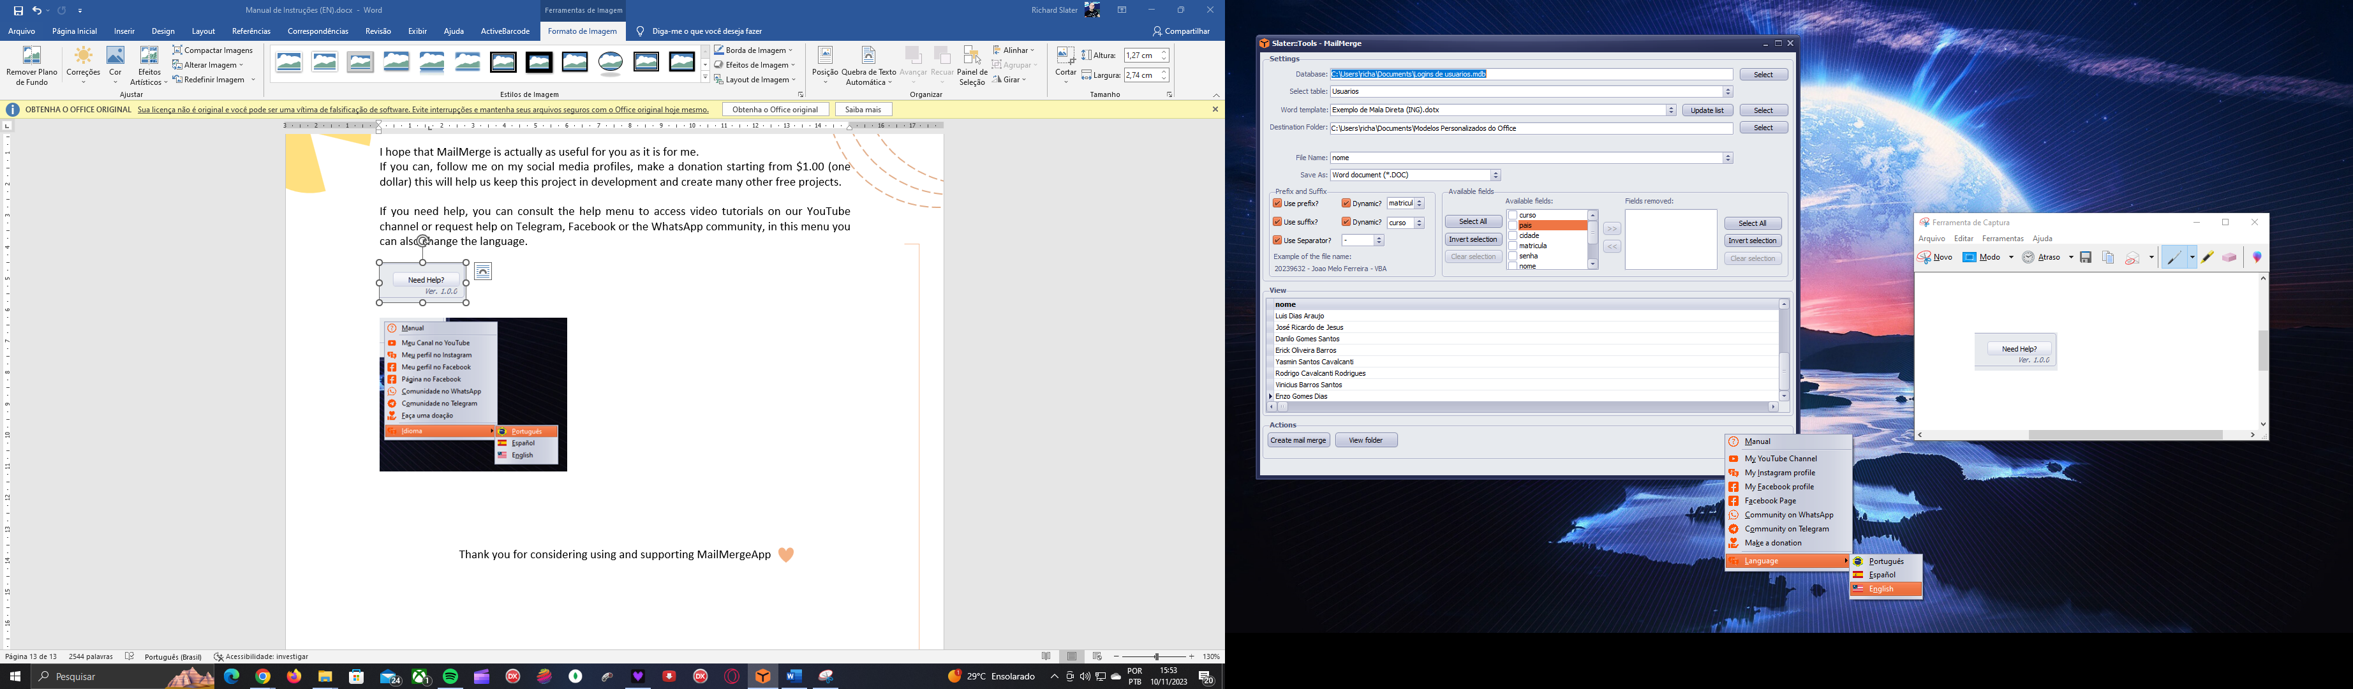

Thank you for considering using and supporting MailMerge App